01st June 2018

**YOKOHAMA showcase at “The Tire”– Cologne 2018**

The Japanese Tyre manufacturer YOKOHAMA is attending “The Tire” trade fair in Cologne from 29th May – 1st June 2018.

The YOKOHAMA booth highlights its commitment to the manufacture and development of premium-car tyres, winter tyres, and “hobby tyres”, which are focal areas for the company and form part of its medium term management plan called GD2020.

The booth introduces visitors to the company’s impressive record as a supplier of original equipment (OE) tyres to many of the world’s premium car models. The “ADVAN Sport V105” is on display as YOKOHAMA’s flagship tyre for high-performance premium cars on a special OE car.

YOKOHAMA is also taking the opportunity to showcase its new products, which were launched as European premieres at the Geneva Motor Show earlier this year. Among these YOKOHAMA’s recently launched first ever European all-season tyre for passenger cars the “BluEarth-4S AW21” is featured and there is also an opportunity to see YOKOHAMA’s studless tyre “iceGUARD iG60” for Nordic winter conditions.

As part of its commitment to developing tyres for the “hobby tyre” market the attractive “GEOLANDAR M/T G003” tyre, designed for SUVs and pickup trucks driving on muddy terrain is also present both at the booth and also fitted on a Mercedes-Benz X-Class pick-up vehicle from the company Delta 4x4 on the outside area. In this outside area, YOKOHAMA also displays one of its 7.5 Ton Motorsport trucks.

As a tribute to the ADVAN brand’s 40th Anniversary, the Japanese company is also highlighting the special celebration within its booth in Cologne and showcases the street sport tyre “ADVAN A052” for the driving enthusiasts of track-days.

YOKOHAMA manufacturers all range of tyres and TBS and OTR products are also on display.

A corner highlighting the Company’s partnership with Chelsea Football Club will also form part of the exhibits which will include displays of the Club’s official shirt with the YOKOHAMA branding.

Additionally the “Alliance 030Ex AL30” passenger car tyre -YOKOHAMA’s second brand, is also smartly presented next to the Chelsea FC corner and opposite from the Alliance Tire Group’s booth which is also part of the YOKOHAMA family.

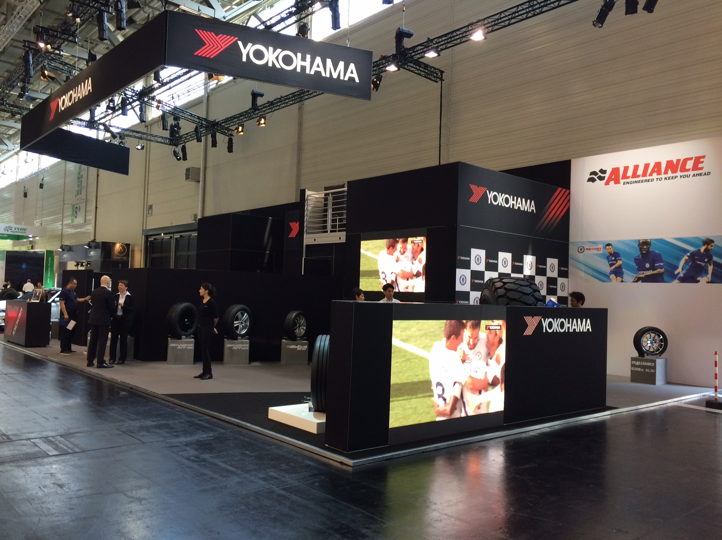

*Yokohama-at-TireCologne*

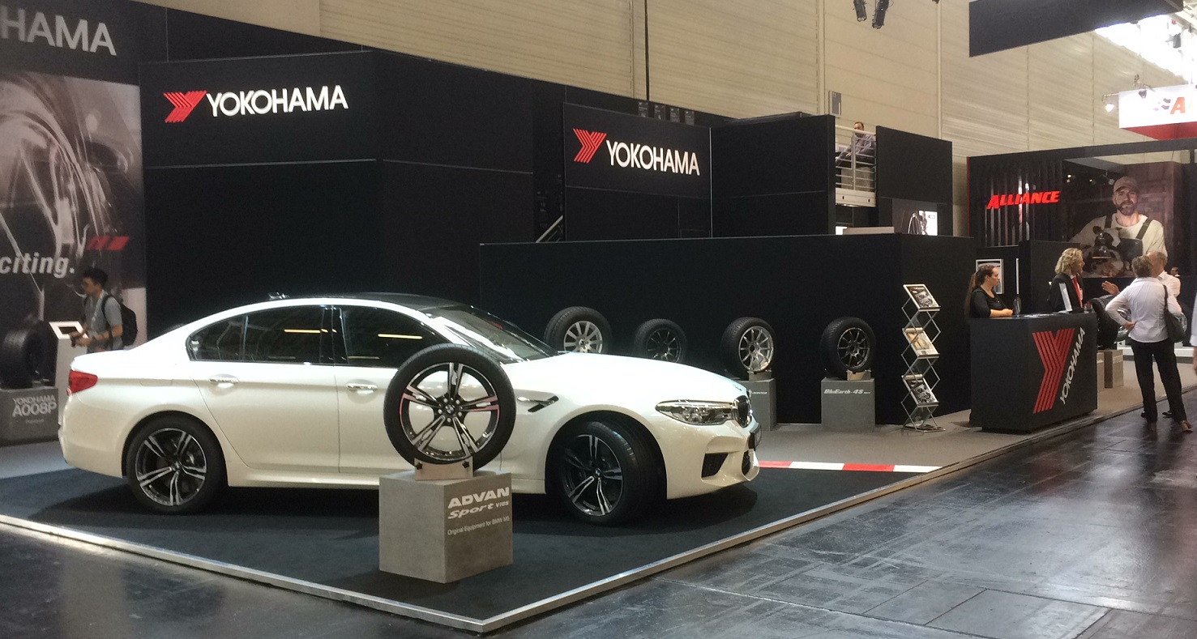

*Yokohama-at-TireCologne-2*